H.T No
Regulations:
A20

Sreenidhi Institute of Science and Technology
(An Autonomous Institution)
Code No: 8A304 Date: 01-Feb-2024 (FN)

B.Tech II-Year I- Semester External Examination, Jan/Feb-2024 (Supplementary)
ELECTRICAL CIRCUITS AND NETWORKS-II(EEE)

Time: 3 Hours Max.Marks:70

Note: a) No additional answer sheets will be provided.
b) All sub-parts of a question must be answered at one place only, otherwise it will not be valued.
c) Missing data can be assumed suitably.
Bloom's Cognitive Levels of Learning (BCLL)

Remember | L1 | Apply | L3 | Evaluate | L5
Understand | L2 | Analyze | L4 | Create | L6

Part - A Max.Marks:20

Answer all QUESTIONS.

 |  | BCLL | CO(s) | Marks
1 | Explain how reactive power can be measured in three phase circuits | L1 | CO1 | [2M]
2 | Define steady state and transient response. | L1 | CO2 | [2M]
3 | List any two properties of transfer function. | L1 | CO3 | [2M]
4 | List Z-parameters interms of Y-parameters. | L1 | CO4 | [2M]
5 | What is band-pass filter. | L1 | CO5 | [2M]
6 | List Disadvantages of Fourier transform? | L1 | CO6 | [2M]
7 | why the voltage across a capacitor cannot change instantaneously. | L2 | CO2 | [2M]
8 | What is a transfer function? | L1 | CO4 | [2M]
9 | Write short notes on Exponential form of Fourier series | L1 | CO6 | [2M]
10 | Define power factor. | L1 | CO1 | [2M]

Part – B Max.Marks:50
ANSWER ANY FIVE QUESTIONS. EACH QUESTION CARRIES 10 MARKS.

 |  |  | BCLL | CO(s) | Marks
11. | a) | A balanced delta connected load of ( 2 +j3) Ω per phase is connected to a balanced three phase 440 V supply. The phase current is 10 A. Find the,  (i) Total active power and (ii) Reactive power | L2 | CO1 | [5M]
 | b) | Explain how power is measured in three phase delta connected balanced load using two wattmeters. | L2 | CO1 | [5M]
12. | a) | Derive the expression for i(t) and voltage across capacitance for series R-C circuit with D.C. voltage applied to it at t = 0 Explain about the time constant of R-C circuit. | L3 | CO2 | [5M]
 | b) | For the circuit shown find the total current assuming that the capacitor is initially uncharged.  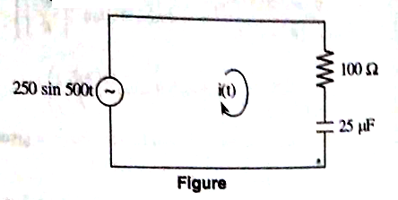 | L4 | CO2 | [5M]
13. | a) | Find the transform impedance of the following circuit shown in figure.  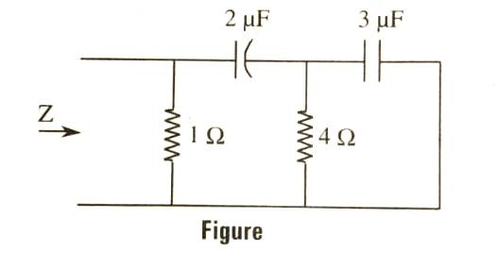 | L2 | CO3 | [5M]
 | b) | What is a driving point function? Explain the necessary conditions for driving point functions. | L2 | CO3 | [5M]
14. | a) | Find the Y-parameters of the network shown in figure.  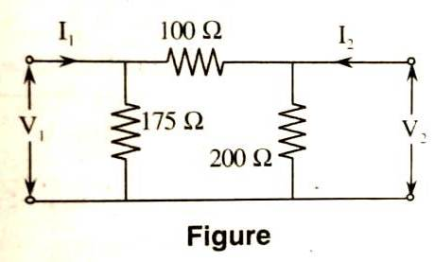 | L2 | CO4 | [5M]
 | b) | Find the ABCD parameters for the following network (figure).  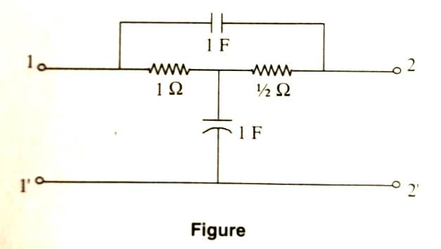 | L2 | CO4 | [5M]
15. | a) | Design a low pass filter (T section) having a cutoff frequency of 2 kHz to operate with a terminated load resistance of 500 Ω | L4 | CO5 | [5M]
 | b) | Derive the characteristic impedance of T-section constant –K high pass filter. | L3 | CO5 | [5M]
16. | a) | Discuss in brief about Fourier integral with expression. | L2 | CO6 | [5M]
 | b) | Calculate the following integrals and functions.  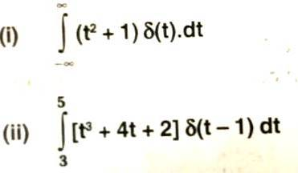 | L2 | CO6 | [5M]
17. | a) | What are advantages of a polyphase system over a single phase system? | L2 | CO1 | [4M]
 | b) | What are the initial conditions? Why do you need them? | L2 | CO2 | [3M]
 | c) | A transfer function is given by 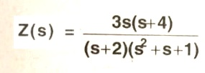  find its pole-zero plot. | L2 | CO3 | [3M]
18. | a) | Obtain the Y-parameter used for parallel connected two port network. | L2 | CO4 | [4M]
 | b) | Explain the analysis of prototype band-pass filter. | L2 | CO5 | [3M]
 | c) | State following propeties of Fourier transform:  (i) Time shifting property  (ii) Frequency shifting property  (iii) Time differentiation and integration property. | L1 | CO6 | [3M]
-- 00 -- 00 –

